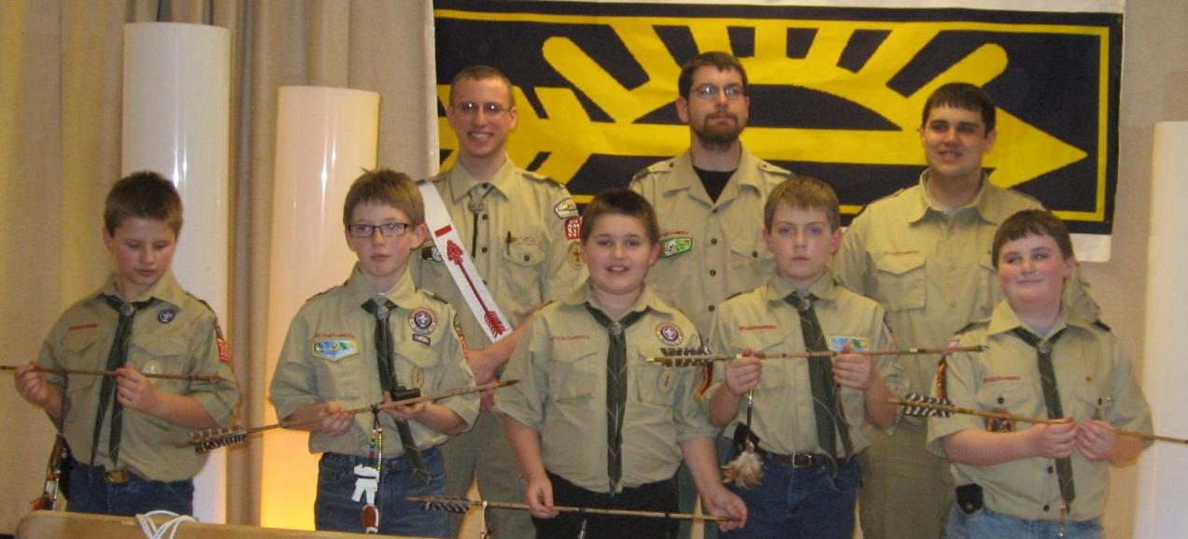Troop 837
ESTABLISHED IN 1937
SPONSORED BY THE KIWANIS OF PORT WASHINGTON
Troop 837 Highlights
- Oriented towards the Patrol Method – the boys learn by doing and helping others!
- Geared to be “Boy Led”- Our young leaders reinforce what they have learned by teaching others!
- Trained adult leadership- concentrating on rank advancement, recognition and FUN!
- Community service projects (Scouting For Food, Fish Day, Highway Cleanup, Little Free Library)
- 100% Summer Camp Attendance in 2013
- Hiking, Camping, Cooking, Orienteering, Canoeing and so much more!!!
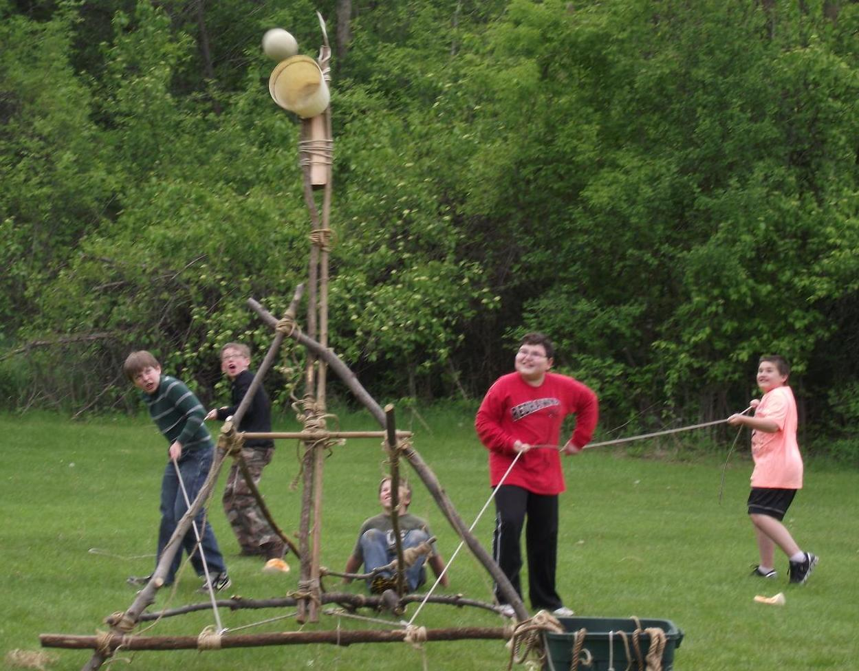
Would you like to learn more about joining Troop 837?
Contact: Scoutmaster- Shannon Perl cell: 262-707-6884 email: shannoncuda@hotmail.com

